**IMPACT OF INFORMATION AND COMMUNICATION TECHNOLOGY (ICT) ON THE SOCIETY**

1.0 **Introduction**

Before we can know about all the impact of information and communication technology, it is essential that we know what information and communication technology is exactly, and its important role in our daily lives. Today information and communication technology involves more than just computer literacy; it also takes into account how computers work and how these computers can further be used not just for information processing but also for communications and problem solving tasks as well.

Our world today has changed a great deal with the aid of information and communication technology. Things that were once done manually or by hand have now become computerized operating systems, which simply require a single click of a mouse to get a task completed. With the aid of ICT we are not only able to stream line our business processes but we are also able to get constant information in ‘real time’ that is up to the minute and up to date.  
  
The significance of ICT can be seen from the fact that it has penetrated almost every aspect of our daily lives from business to leisure and even society. Today **personal computer (PCs), cell phones, TV, radio, fax machines, pagers, email and internet** have all not only become an integral part of our very culture but also play an essential role in our day to day activities.

With such a wide scope, let us have a definition of information and communication technologies.

Definition: *Information and Communication Technologies can be defined as the generic term used to express the convergence of information technology, broadcasting and communications*, e.g. Internet.

**IMPACT OF ICT ON THE SOCIETY (Some advantages)**

**1.1 (a) The role of ICT in:**

**Education:**

▪  Either Students or teachers records processing and keeping.

▪  As a computer aided instruction (CAI) and computer aided learning (CAL),

▪  Used to access learning materials i.e. searching in internet.

▪  Help in development of open universities (distance learning)

▪  As a research tool e.g. to analyze data from experiment.

▪  To assist education management  
  
**Industry and Engineering:**

▪  To design drawings for products using Computer Aided Design (CAD) programs e.g. airplanes, bridges, cars, buildings and electronic circuit boards.

▪  To manufacture products by using Computer Aided Manufacture (CAM).

▪  To plan and control major project.

▪  To simulate – to predict in a real life situation from a model situation e.g. timing of traffic lights.

▪  To control some operations in automobiles e.g. mixed of fuel and air enter the engine

▪  A branch of a computer science called artificial intelligence uses programs that help to solve problems by applying human knowledge and experience e.g. in medicine and law.

**Banking and Business:**

▪  To allow banker clerk and custom to find bank balances in an account

▪  To help bankers to record money paid in and out.

▪  To allow people to use automatic teller machine (ATM) in cash withdraw and transfer of funds between accounts.

▪  To keep track of current prices of market stocks, bounds currency.

▪  Creates an effective way of producing documents e.g. reports, brochures and cards

**Military uses:**

▪  It can be use for planning and decision making.

▪  It can be used for planners to stimulate wars.

▪  It can be used it guide modern weapons such as missiles and field artillery.

**In a Government:**

▪  It can be used for internal revenue services e.g. to provide reports for tax purposes.

▪  It can be used for planning analysis, forecast, sampling, predictions etc.

▪  It can be used for weather forecast

▪  It can be used for law enforcement.

**In Communication: (**Telecommunication)

▪Communication has also become cheaper, quicker, and more efficient. We can now communicate with anyone around the globe by simply text messaging them or sending them an email for an almost instantaneous response. The internet has also opened up face to face direct communication from different parts of the world thanks to the helps of video conferencing.

▪Telephone switching (automatic routing and connections of calls) transmission of computer data via network and electronic mail.

▪Transportations connections; time table, scheduling times, road, airways, railways etc.

**In an entertainment:**

▪  To play Games

▪  To watch moves

▪  Chatting through E-mail

▪  Listening from music

▪  Reading

**Management:**

▪  Files management

▪  Office record keeping

**Cost effectiveness*:***

Information and communication technology has helped to computerize the business process thus streamlining businesses to make them extremely cost effective money making machines. This in turn increases productivity which ultimately gives rise to profits that means better pay and less exhausting working conditions. Although the cost factor is still a challenge in general, the relative cost of ICT has greatly fallen over the past years and it continue to fall.

**Creation of new jobs***:*

Probably the best advantage of information and communication technology is the creation of new and interesting jobs. Computer programmers, Systems analyzers, Hardware and Software developers, radio/TV presenter, Phone shops, ICT technician and Web designers are just some of the many new employment opportunities created with the help of ICT.

**More time*:***

ICT has made it possible for businesses to be open 24hr all over the globe. This means that a business can be open anytime anywhere, making purchases from different countries easier and more convenient. It also means that you can have your goods delivered right to your doorstep without having to move a single muscle. Not yet full practice in Tanzania.

**Speed**:

Simultaneous information in writing, sound and picture can be exchanged within a fraction of seconds around the clock. Moreover, the internet allows real time ‘many to many’ interactions.

**Integration**:

ICT allow for the integration of different types of media. For instance, the combination of a local radio with the Internet allow access not only to much wider range of information sources but also the efficient exchange of broadcasting modules, making e.g. censorship(restriction) more difficult.

1.1 (b) **The role of ICT in making awareness in: Gender, HIV/AIDS, Drug/drug Abuse and**

**Corruption:**

The role of ICT is to spread information.

Information about Gender, HIV/AIDS, Drug/drug Abuse and Corruption is dispread and received all over the world through communication media such as TV, Radio, CD-ROMs, News Papers and Computer internet etc.

**Gender sensitive:**

•         Girls and boys have equal right to join the school.

-People attending different forums/semina which talk about gender issues,gender equity,gender discrimination,

•         Woman have right to own land

Previous years women were not allowed to own the land but now to gender reschedule now woman have the right to own the land but due to rigidity in some culture there are still practicing these gender imbalance.

Though different conferences/forum/semina people are getting knowledge on there right.All these have been presented in different platform.

•         Violate to women

Some tribes are still biting the women due to the mistake either caused by the man or the women then these end up causing serious injuries to the women.

Though getting education on how to treat the women,different tribe now they have developed the new customs which are safeguarding the women.

Some tribe

•         Biasness

•         Rap

Though television there is many program arranged to give education on the transmission of diseases, eg HIV/AIDS.

The way the disease transmit and affect the

**HIV transmission ways:**

•         unsafe Sexual intercourse.-Having sexual intercourse with the affected person without following doctors advise.

Sexual intercourse when one is not aware and not prepared(Rape)

•         Blood transmission (unsafe blood)

•         Untreated injection exchanging

•         Sharp objects which can cause the blood to move from one person to another.

**HIV precaution ways:**

•         To stop sex

•         To have only one lover

•         To use condom(which is always not 100%)

 In television and radios there are different announcement/seminas which are telling us on how to live with HIV/AIDS victims.

**HIV/AIDS victims:**

•         To attend counseling and guidance to professional counselor

•         To attend treatment

•         Not to isolate them (stigmatization)

•         To provide them with a balance diet

•         To visit to their home, to comfort and show them love

**Effectc**

**Drug/drug Abuse:**

•         Mental disturbance

•         HIV transmission way

•         Luck of education

**Corruption:**

To misuse the leadership power

To go against human rights

**Globalization:**

ICT has not only brought the world closer together, but it has allowed the world’s economy to become a single interdependent system. This means that we can not only share information quickly and efficiently, but we can also bring down barriers of linguistic and geographic boundaries. The world has developed into a global village due to the help of information and communication technology allowing countries like Chile and Japan who are not only separated by distance but also by language to shares ideas and information with each other.

**Family life:**

▪  Home budget

▪  Shopping timetable

▪  Home records keeping

▪  Reading news and stories

▪  Refreshment i.e. games and movies

**Culture changes**

***Bridging the cultural gap(interactivity)*** – Information and communication technology has helped to bridge the cultural gap by helping people from different cultures to communicate with one another, and allow for the exchange of views and ideas (facilitate dialogue), thus increasing awareness and reducing prejudice. With ICT local radios can be much more interactive and run   
more economically than a decade ago.

**Road safety (**Transportation**):**

▪  Traffic control

▪  Driving simulators

▪  Reservation systems

▪  Are embedded in air traffic to provide efficiency in flying.

▪  Traffic signs and their interpretations

**Some disadvantages of ICT include:**   
  
**Unemployment:**

While information and communication technology may have streamlined the business process it has also crated job redundancies, downsizing and outsourcing. This means that a lot of lower and middle level jobs have been done away with causing more people to become unemployed.  
  
**Privacy:**

Though information and communication technology may have made communication quicker, easier and more convenient, it has also bought along privacy issues. From cell phone signal interceptions to email hacking, people are now worried about their once private information becoming public knowledge.

**Lack of job security:**

Industry experts believe that the internet has made job security a big issue as since technology keeps on changing with each day. This means that one has to be in a constant learning mode, if he or she wishes for their job to be secure.  
 **Dominant culture:**

While information and communication technology may have made the world a global village, it has also contributed to one culture dominating another weaker one. For example it is now argued that US influences most young teenagers all over the world now in terms of act, dress and behave. Languages too have become overshadowed, with English becoming the primary mode of communication for business and everything else.

**Health risk (hazards):**

•         Eye strain; if you are looking at computer monitor for too long.

•         Neck/ back strain; this is caused by poor seating arrangement.

•         Repetitive strain injury (RSI); this is from using a keyboard for too long.

•         Fitness problems; from lack of exercise.

ICT are based on digital information held as 1s and 0s, and comprises the hardware (i.e. Computer set, Handset of Mobile phone), Software and Networks.

There are also other technology apart from digital, others include:

* “Intermediate” technology, still based largely on analogy information held as electromagnetic waves such as radio, television and telephone.
* “Literate” technology, based on information held as the written word such as books and newspapers
* “Organic” technology, based solely on the human body such as brain and sound waves.

Therefore in building up the model of ICT, two **separate elements** have already been identified: **The technology (1)** and the **information on which it operates (2)**. Other elements are **IS (Information System- collection of hardware, software, people, procedures, and data)** and **Institutional and other influencing factors** (e.g. Political, economic, socio-cultural, technical and legal).

1.2 **ICT and Crimes:**

Some criminal cases in ICT include:

✓  Viruses’ transmission

✓  Junk mail

1.3 **Information security (Loss of secrecy)**

Computer Security

**INTRODUCTION**

Computer Security, techniques developed to safeguard information and information systems stored on computers. Potential threats include the destruction of computer hardware and software and the loss, modification, theft, unauthorized use, observation, or disclosure of computer data.

Computers and the information they contain are often considered confidential systems because their use is typically restricted to a limited number of users. This confidentiality can be compromised in a variety of ways. For example, computers and computer data can be harmed by people who spread computer viruses and worms. A computer virus is a set of computer program instructions that attaches itself to programs in other computers. The viruses are often parts of documents that are transmitted as attachments to e-mail messages. A worm is similar to a virus but is a self-contained program that transports itself from one computer to another through networks. Thousands of viruses and worms exist and can quickly contaminate millions of computers.

People who intentionally create viruses are computer experts often known as hackers. Hackers also violate confidentiality by observing computer monitor screens and by impersonating authorized users of computers in order to gain access to the users’ computers. They invade computer databases to steal the identities of other people by obtaining private, identifying information about them. Hackers also engage in software piracy and deface Web sites on the Internet. For example, they may insert malicious or unwanted messages on a Web site, or alter graphics on the site. They gain access to Web sites by impersonating Web site managers.

Malicious hackers are increasingly developing powerful software crime tools such as automatic computer virus generators, Internet eavesdropping sniffers, password guessers, vulnerability testers, and computer service saturators. For example, an Internet eavesdropping sniffer intercepts Internet messages sent to other computers. A password guesser tries millions of combinations of characters in an effort to guess a computer’s password. Vulnerability testers look for software weaknesses. These crime tools are also valuable security tools used for testing the security of computers and networks.

An increasingly common hacker tool that has gained widespread public attention is the computer service saturator, used in denial-of-service attacks, which can shut down a selected or targeted computer on the Internet by bombarding the computer with more requests than it can handle. This tool first searches for vulnerable computers on the Internet where it can install its own software program. Once installed, the compromised computers act like “zombies” sending usage requests to the target computer. If thousands of computers become infected with the software, then all would be sending usage requests to the target computer, overwhelming its ability to handle the requests for service.

A variety of simple techniques can help prevent computer crimes, such as protecting computer screens from observation, keeping printed information and computers in locked facilities, backing up copies of data files and software, and clearing desktops of sensitive information and materials. Increasingly, however, more sophisticated methods are needed to prevent computer crimes. These include using encryption techniques, establishing software usage permissions, mandating passwords, and installing firewalls and intrusion detection systems. In addition, controls within application systems and disaster recovery plans are also necessary.

**BACKUP**

Storing backup copies of software and data and having backup computer and communication capabilities are important basic safeguards because the data can then be restored if it was altered or destroyed by a computer crime or accident. Computer data should be backed up frequently and should be stored nearby in secure locations in case of damage at the primary site. Transporting sensitive data to storage locations should also be done securely.

**ENCRYPTION**

Another technique to protect confidential information is encryption. Computer users can scramble information to prevent unauthorized users from accessing it. Authorized users can unscramble the information when needed by using a secret code called a key. Without the key the scrambled information would be impossible or very difficult to unscramble. A more complex form of encryption uses two keys, called the public key and the private key, and a system of double encryption. Each participant possesses a secret, private key and a public key that is known to potential recipients. Both keys are used to encrypt, and matching keys are used to decrypt the message. However, the advantage over the single-key method lies with the private keys, which are never shared and so cannot be intercepted. The public key verifies that the sender is the one who transmitted it. The keys are modified periodically, further hampering unauthorized unscrambling and making the encrypted information more difficult to decipher.

**APPROVED USERS**

Another technique to help prevent abuse and misuse of computer data is to limit the use of computers and data files to approved persons. Security software can verify the identity of computer users and limit their privileges to use, view, and alter files. The software also securely records their actions to establish accountability. Military organizations give access rights to classified, confidential, secret, or top-secret information according to the corresponding security clearance level of the user. Other types of organizations also classify information and specify different degrees of protection.

**PASSWORDS  
Smart Card**

Smart cards, like this one for an employee of the Microsoft Corporation, are becoming increasingly common as security devices for accessing computer networks and corporate buildings. In addition to an identifying photograph, the smart card contains an embedded microchip on the reverse side that stores data about the user, including a password that changes periodically. This information is read by a device attached to a computer and ensures that only authorized persons can access a corporation's internal computer network.

Kathleen Green

Passwords are confidential sequences of characters that allow approved persons to make use of specified computers, software, or information. To be effective, passwords must be difficult to guess and should not be found in dictionaries. Effective passwords contain a variety of characters and symbols that are not part of the alphabet. To thwart imposters, computer systems usually limit the number of attempts and restrict the time it takes to enter the correct password.

A more secure method is to require possession and use of tamper-resistant plastic cards with microprocessor chips, known as “smart cards,” which contain a stored password that automatically changes after each use. When a user logs on, the computer reads the card's password, as well as another password entered by the user, and matches these two respectively to an identical card password generated by the computer and the user's password stored in the computer in encrypted form. Use of passwords and 'smart cards' is beginning to be reinforced by biometrics, identification methods that use unique personal characteristics, such as fingerprints, retinal patterns, facial characteristics, or voice recordings.

**FIREWALLS**

Computers connected to communication networks, such as the Internet, are particularly vulnerable to electronic attack because so many people have access to them. These computers can be protected by using firewall computers or software placed between the networked computers and the network. The firewall examines, filters, and reports on all information passing through the network to ensure its appropriateness. These functions help prevent saturation of input capabilities that otherwise might deny usage to legitimate users, and they ensure that information received from an outside source is expected and does not contain computer viruses.

**INTRUSION DETECTION SYSTEMS**

Security software called intrusion detection systems may be used in computers to detect unusual and suspicious activity and, in some cases, stop a variety of harmful actions by authorized or unauthorized persons. Abuse and misuse of sensitive system and application programs and data such as password, inventory, financial, engineering, and personnel files can be detected by these systems.

**APPLICATION SAFEGUARDS**

The most serious threats to the integrity and authenticity of computer information come from those who have been entrusted with usage privileges and yet commit computer fraud. For example, authorized persons may secretly transfer money in financial networks, alter credit histories, sabotage information, or commit bill payment or payroll fraud. Modifying, removing, or misrepresenting existing data threatens the integrity and authenticity of computer information. For example, omitting sections of a bad credit history so that only the good credit history remains violates the integrity of the document. Entering false data to complete a fraudulent transfer or withdrawal of money violates the authenticity of banking information. These crimes can be prevented by using a variety of techniques. One such technique is *check summing*. Checksumming sums the numerically coded word contents of a file before and after it is used. If the sums are different, then the file has been altered. Other techniques include authenticating the sources of messages, confirming transactions with those who initiate them, segregating and limiting job assignments to make it necessary for more than one person to be involved in committing a crime, and limiting the amount of money that can be transferred through a computer.

**DISASTER RECOVERY PLANS**

Organizations and businesses that rely on computers need to institute disaster recovery plans that are periodically tested and upgraded. This is because computers and storage components such as diskettes or hard disks are easy to damage. A computer's memory can be erased or flooding, fire, or other forms of destruction can damage the computer’s hardware. Computers, computer data, and components should be installed in safe and locked facilities.

1.4 **ICT and employment:**

This part is still a debate in ICT, simple because to some people are in advantage side but some are in disadvantage side.

**Creation of new jobs***:*

Probably the best advantage of information and communication technology is the creation of new and interesting jobs. Computer programmers, Systems analyzers, Hardware and Software developers, radio/TV presenter, Phone shops, ICT technician and Web designers are just some of the many new employment opportunities created with the help of ICT.

**Unemployment**

While information and communication technology may have streamlined the business process it has also crated job redundancies, downsizing and outsourcing. This means that a lot of lower and middle level jobs have been done away with causing more people to become unemployed. The ability of the computer to handle high volume of jobs may cause loss of employment in specific field.

1.5 **ICT and Culture interaction**

**Bridging the cultural gap (interactivity)**

Information and communication technology has helped to bridge the cultural gap by helping people from different cultures to communicate with one another, and allow for the exchange of views and ideas (facilitate dialogue), thus increasing awareness and reducing prejudice. With ICT local radios can be much more interactive and run   
more economically than a decade ago. People ca interact one another via radio, TV, computer, Recorder, DVD player, tabloid on dressing

1.6 **ICT Hazard**

It is restricted that don’t expose the electronic equipments to the environment.

The Health hazards of ICT**:**

•         Eye strain; if you are looking at computer monitor for too long.

•         Neck/ back strain; this is caused by poor seating arrangement.

•         Repetitive strain injury (RSI); this is from using a keyboard for too long.

•         Fitness problems; from lack of exercise.

**Negative effects of the ICT:**

The internet is the worldwide publicly accessible network of interconnected computer networks. In this case it is possible to find some information, pictures, news or stories etc which are not good from one society to another or one country to another.  
Nowadays there are some web sites accessing different pictures or messages which are unethical manner e.g. sex. This is not acceptable in some countries such as Tanzania. Also you can find that, through internets some African people are nowadays left out African culture and follow western countries culture. These including the way they wear clothes, types of food, greetings, usage of language etc.

## TOPIC :3 DATABASE AS INFORMATION SYSTEM

3.0 Database is a collection of related files. Or Database is a collection of integrated data.

3.1 Manual data Processing System: Refers as Traditional way of data processing. These are pencil and paper data processing.

3.2    Electronic data Processing System: refers as Modern way of data processing. These data are made up by computer. They are ease to format, edit, remove or add the content

|  |  |
| --- | --- |
| **Manual data Processing System:** | **Electronic data Processing System** |
| Low technology data processing (e.g. pencil and paper) | Very high technology data processing (e.g. computer) |
| Difficult to adjust | Ease to adjust i.e. editing, formatting |
| Difficult to produce copies with the same quality | Ease to produce more copies with the same quality |
| It takes time to produce data required | It takes very short time to produce data required (depends on user operating speed) |
| Difficult to move to different location | Can move to a different location easily |
| Can not be printed | Information can be printed |
| Generally not easy to read | Generally easy to read |

3.3    The importance of data processing:

v  To have records to be use on future

v  To be up-to-date

v  Secure

v  Plan for the future

3.4    **Database terminologies:-**

* **Data Organization**- To be processed by the computer or stored in secondary storage, data is typically organized into groups or categories. Each group is more complex than the one before as shown below:
* **Character:** Is a single letter, number, or special character such as punctuation mark or $.
* **Field:** Contain a set of related characters. E.g. a word such as “Caesar”
* **Record:** Collection of related field.
* **File**: Collection of related records
* **Database:** Collection of related files.

3.5    **Database Management System**

In order to create, modify, and gain access to database the special software is required. This software is called Database Management System (DBMS)

ABMS is made up of a data dictionary and query language.

3.6    **Importance of database system**

o   **Sharing**: In Organizations, information from one department can be ready shared with others

o   **Security:** Users are given passwords or access only to the kind of information they need to know e.g. payroll department may have access to employee’s pay rates, but other department would not.

o   **Fewer files**: With several departments having access to one file, there are fewer files.

o   **Data integrity:** Order filing systems many times did not have” integrity” that is a change made in a file in one department might non be made in the file in another department

3.7    **Types of Database:**

There are (4) kinds Databases

(i)      **Individual**: is also called microcomputer database. It is a collection of integrated file primarily used by just one person

(ii)    **Company:** May be stored on a mainframe computer and managed by a computer professional (database administrator) users throughout the company have access to the database through their microcomputers linked to local area networks or wide area networks. There are two types of company database (1) common operational database (2) common user database.

(iii)   **Distributed:** That is, it is located in a place(s) other than where users are located. Typically, database savers on a client/sever network provide a link between users and the distant data. E.g. information can be at regional offices. Some can be at headquarters, some down the hall from you and some even overseas

(iv)    **Propriety:** Is generally an enormous database that an organization develops to cover certain particular subject. It offers access to this database to the public or selected outside individuals for fee.

3.8    **Creating database:**

**What is Microsoft Access?**

* Microsoft Access is a Database Management Program
* Database is a collection of related files

**Main objects in a database are:-**

o   Tables – Used to store data in a database

o   Queries- Used to search for specific information in database tables

o   Forms – Used to display data from database tables, Queries & also are used to enter, edit data in tables

o   Reports- Used to present data for printing.

**Tables**

* Tables are containers used to store data in a database
* Data in tables is stored in fields(columns) and records (rows)

**Starting MS - Access**

* Click on Start button
* Click on Programs
* Click on Microsoft Access

OR

* Click on Start button
* Click on RUN
* Type MSACCESS
* Click OK

**Creating a Table Using Design View**

* On database window, click on Tables Objects
* Double-click on ‘Create a table using design view’
* OR ‘Click on New, click on Design View, Click OK’
* On Design view, enter the field names and select their respective data types and if needed enter the description for the fields.
* Specify the properties for the fields (field size, format e.t.c) if necessary, specify the primary key field.
* Save the table
* Close the table

**Creating a table using Wizard**

* On database window, on Tables objects
* Double click on ‘Create a table using Wizard’
* Select category, select sample table, select fields you want, Click on Next
* Enter table name, specify how you want the primary key to be created, click Next
* On the last step, specify how you want the table opened, Click on Finish

**Creating a Primary key field**

* On Table’s design view
* Right-click on a field you want to be a Primary key field
* On the menu appearing, click on Primary Key.

**FILTERS**

* Filters are used to narrow the list of records displayed
* A filter looks for specific information in each record and then lists only those records that contain that specific information.

**Filter by Selection**

* Open the table on which you want to filter
* Click on the field with the value you want to filter
* Click on the Filter by Selection button on the toolbar

**OR**

* Right-click on the field with the value to filter
* Click on Filter by Selection on menu appearing

**Filter Excluding Selection**

* On the table on which you want to filter
* Right-click on the field with the value to exclude
* Click on Filter Excluding Selection on menu appearing

**Filter by Form**

* Open the table on which you want to filter
* Click on Filter by Form button on the toolbar
* The filter window may contain previous filters, click on Clear Grid button on the toolbar to remove
* Enter the filters you want
* Click on Apply Filter button on the toolbar to view the results

**Removing Filter**

* On Filtered view
* Click on Remove Filter button on the toolbar to see all the records

**QUERIES**

* Access refers to the process of questioning, selecting and manipulating data as Querying.
* Queries are used to search for a specific data contained in a table.

**Creating a Query using Design View**

* On database Window, click on queries objects
* Double-click on ‘Create Query using Design View’
* OR Click on New, Click on Design View, Click OK
* On Show table window, click on a table you want for the query to get its values from
* Click OK. If it’s more than one table, then continue to add the tables in the same way
* Click close to close the show table window.
* In query’s design view, the user has to add the fields for the query on field row by:
  + Double-click on a field OR
  + Drag the field to the field row
* Add criteria, calculated fields etc if needed.
* View the query in datasheet view to see how the resulting query looks like
* Save the query.

**Creating Query Using Wizard**

* On database Window, make sure you are Queries Objects
* Double-click on ‘Create Query using Wizard’
* OR Click on New, Click on Simple Query Wizard, Select OK
* Select the table/query where you want the query to get its values from on tables/queries box
* Select the fields, click Next
* Follow the wizard steps and select options you want
* On the last step, enter the query name, select where you want the query to be opened
* Click Finish

**Creating a calculated field on Queries**

* On Query’s design view
* On field row, click on the empty cell on field row
* Type the field name, and the formula (how the field is going to get its values), the field name and the formula are being separated by a double colon (:)

**FORMS**

* Forms in Access are like any forms we usually fill in our everyday life.
* Forms in Access are used to enter data in tables, to view existing data in queries tables and also to edit data in our databases tables.
* The easiest way to create a form is by using Form Wizard and after creating you can switch to design view and customize the form.

**Creating a Form Using Form Wizard**

* On Database window, click on Forms Objects.
* Double-click on ‘Create a Form using Wizard’
* OR ‘Click on New, click on Form Wizard, Click OK’
* Select the table / query where you want the form to get its values from
* Select the fields you want for the form, click Next
* Select the Form Layout, click Next
* Select the style, click Next
* Enter the Form Name
* Select on which view you want the form to be opened
* Click on Finish

**Creating A Form Using Autoform**

* On Database window, on Forms objects
* Click on New
* Select the type of Autoform you want
  + Autoform: Columnar
  + Autoform: Tabular
  + Autoform: Datasheet
  + Select the table/query you want the form to get its values from
  + Click OK

**Formatting Form’s Controls**

* On Form’s Design View
* Click on form’s controls to select
* Use Formatting toolbar to format the control(s)

**Showing / Hiding Toolbox on Form’s Design View**

* On Form’s Design view
* Click on View Menu
* Click on Toolbox

**Creating a Label on a Form**

* On Form’s Design view
* On Toolbox, click on Label control
* Click on a Form where you want the label to appear
* Type the label name
* Press Enter to select the label
* Use formatting toolbar to format the label

**REPORT**

* Report is the flexible means of presenting and displaying your data in a database.
* In a report, data can not be modified or deleted, you can only view data.
* The easiest way to create a report is by using wizard

**Creating a report using a wizard**

* On database window, click on Report Objects
* Double-click on ‘Create Report using a wizard’
* OR Click on New, Click on Report Wizard, Click OK
* Select the table/query where you want the report to get its values from
* Select the fields, click Next
* Add grouping level(s), Click Next
* If necessary add sort order for the detail records AND if any of the fields selected for the report has Currency or Number data type, then you will have Summary Options button allowing you (the user) to add calculated value e.g. sum, average etc
* Click Next
* Select the layout you want, Click Next
* Select the style, Click Next
* Enter the report name and where do you want the report to be viewed.
* Click Finish.

**Renaming database objects e.g. tables, forms, queries etc**

* On database window,
* Right click on the object you want to rename
* On the menu appearing, click on Rename
* Type the new name
* Press ENTER

**Deleting database objects**

* On database window
* Click on the object you want to delete
* Press DELETE on keyboard

OR

* On database window
* Right-click on the object to delete
* Select Delete on menu appearing

**Sending a database to floppy diskette (A)**

* Close the database
* Go to where Database file is saved e.g. to My Document, on desktop etc.
* Find the database you want to send to the diskette
* Right-click on it
* On the menu appearing, click on send to
* Click on 3½ floppy(A)

## TOPIC:2 WEB DEVELOPMENT

**Web development (Web Page design)**

This topic is all about creating a Multi-media World Wide Web (WWW) site that **informs and entertains**. It is an evolving course and focuses on the production of multi-media content (WWW) using web design software (e.g. Java HTML script, FrontPage). The goal of this topic is for you to create a media enriched WWW site.

The software used to create website are:

* Text editors e.g. Notepad and WordPad etc
* Macromedia Dreamweaver
* HTML Kit
* Microsoft Home page
* Microsoft FrontPage etc

In this chapter, you will be using Simple Text editors and FrontPage to create and maintain your WWW site, which will be stored on a secure server/hard disk.

2.1.1 **Introduction to webpage design**

If you have mastered this topic, you should be able to use the following terms correctly in your assignments and exams:

* **HTML:** Stand for Hypertext Markup Language, a simple scripting language to create a webpage
* **Hypertext:** Simply a piece of text that works as a link
* **Markup Language:** is a way of writing layout information within documents
* **Tag:** is a markup for telling the browser
* Make sure you know who your **audience** is. For example customers, Employees, Students, Friends, Family.
* If you are making a site for your company, make sure the **goal** is **specific** and **quantitative**.
* **Keep your goal simple**. A couple of sentences or a short paragraph is enough. If your goal is too long, your site will end up looking like it's trying to do too much.
* **Script:** A list of commands that can be executed without user interaction
* **Script language:** A simple programming language which you can write scripts
* **Perl:** Script programming language that is similar in syntax to C language
* **ASP:** Server side scripting language that can be included inside HTML file.

**Microsoft FrontPage**

A program you can use to create and manage Internet and intranet sites without programming; FrontPage is available as part of one of the Microsoft Office suites or as a stand-alone product.

**What is a FrontPage Web site?**

* A FrontPage Web site is a site created in FrontPage. It contains Web pages, graphics, documents, multimedia almost any kind of file you want.
* More importantly, a FrontPage Web site also contains hidden folders and files that support FrontPage specific functionality. These hidden items are the FrontPage metadata for your site. Don't let this term intimidate you; as you'll see in a second, FrontPage metadata is really quite simple.

**Two kinds of FrontPage Web sites**

* Now that you know what a FrontPage Web site is, it's important to know that there are two kinds: **disk-based** and **server-based**.
* In short, a disk-based site is a FrontPage Web site you create on your local hard disk and then later publish to a Web server. A server-based site is one you create and work with directly on a Web server, without the extra step of publishing.

2.1.2 **Prepare webpage structure**

* Once your site's goal is defined, we recommend **sketching out the structure of your site** beforehand.
* Use a pencil and paper (or a diagramming tool, like Microsoft® Visio®) to draw boxes for pages and arrows for links. Remember to keep your goal in mind as you do this.
* This is essentially the process of creating a visual outline. And it will save you a lot of time to do this on paper before your site is constructed. Just think: It's easier to erase a few boxes and start over than it is to delete and rebuild pages in an already-built Web site.

**Sketch a common layout**

After you've sketched a map of your site, it's time to start sketching a common layout for each of your pages.

Some of the things you will want to consider as you are sketching the layout are:

* Should your site have a header and footer that are common to each page?
* Should your site have a consistent method of navigation on each page?
* Do you have any marketing requirements that must be fulfilled? For example, should you stick to certain fonts and color schemes?
* Does your site need any legal requirements, like a copyright notice?

**Later, when you're ready**

* Using your sketches as a model, you'll eventually use FrontPage to design Web pages in HTML. You might use a table for the skeletal structure, or layout, of the page.
* Once the layout is defined, you can fill it with content. For example, you'll want to add text, hyperlinks, pictures, and interactive buttons.

2.1.3 **Create webpage using HTML**

**INTRODUCTION**  
HTML pages are used for specifying web page content. They contain information and instructions to web browsers that inform them of what to display, and how it should be displayed. It is a simple format, easily learnt, and can support a number of media devices, such as sound, graphic images, and video.

HTML documents are ASCII files, and are created using a simple text editor (or an editor like Front Page). With a text editor, you cannot see what the code looks like in the browser, unless you save the page and then load it into the browser for viewing. WYSIWYG (What you see is what you get) editors like Front Page allow you to view the page as it is constructed in the editor window.

One advantage of using a simple text editor is that you have more control over the HTML code; the disadvantage is you must know the code and have a picture in your mind as to what it looks like. Another disadvantage is since HTML is becoming more complex, it is harder to write, and sophisticated editors like Front Page support the advanced features making it easier for you to implement them.

HTML is a series of tags enclosed in **<** and **>** brackets. For instance,is an HTML tag that defines a head section of an HTML document. Certain characters are reserved, such & < > which are interpreted as HTML codes.

Each HTML page adheres to a basic structure. This looks like

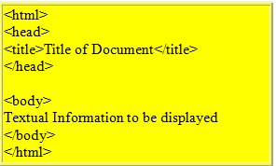

When viewed in the browser, this page looks like,

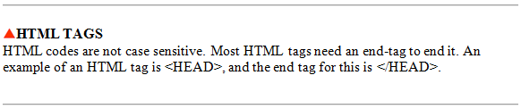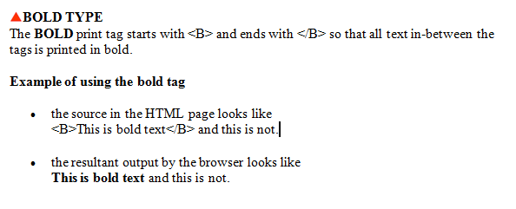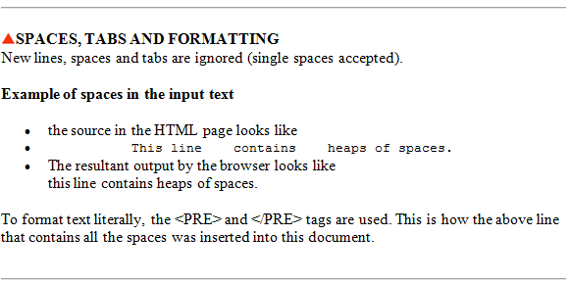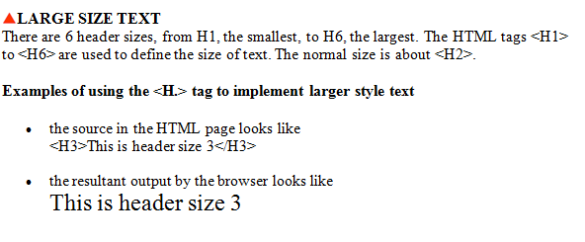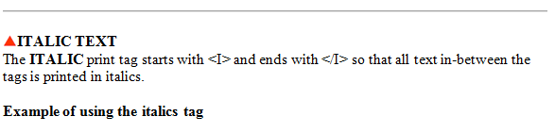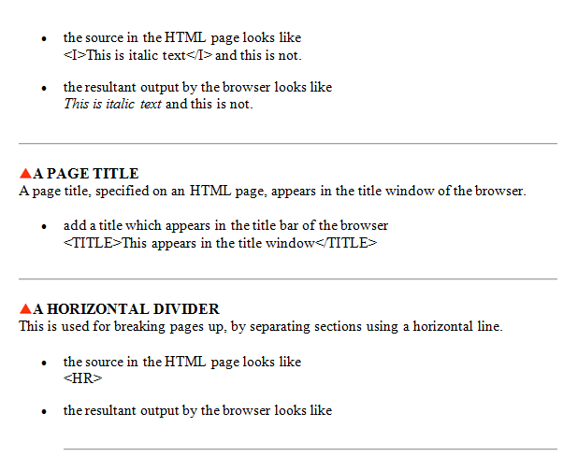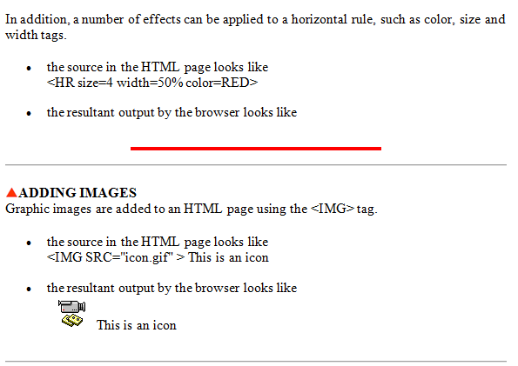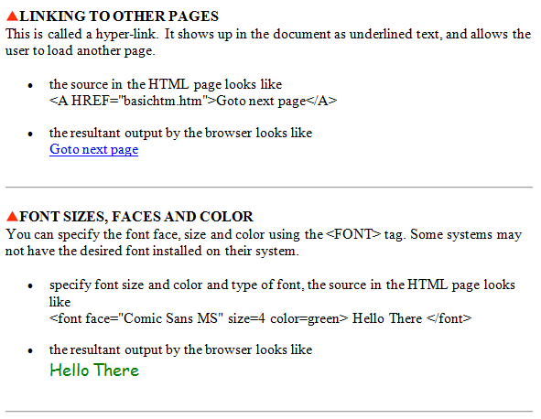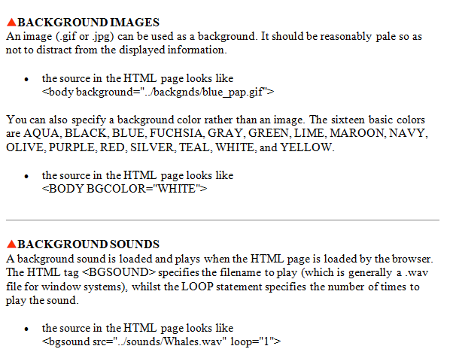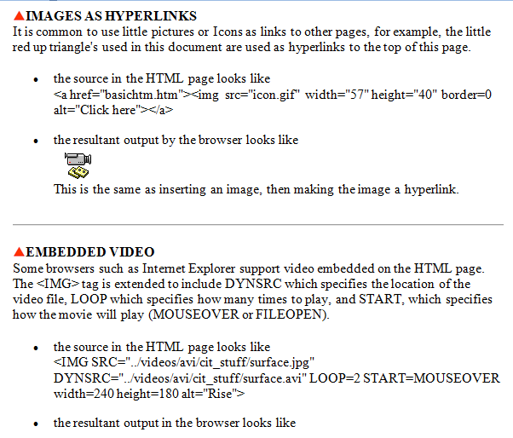

* All normal WebPages consist of a head and a body.

|  |
| --- |
| Head |
| Body |

* The head is used for text and tags that do not show directly on the page.
* The body is used for text and tags that are shown directly on the page.

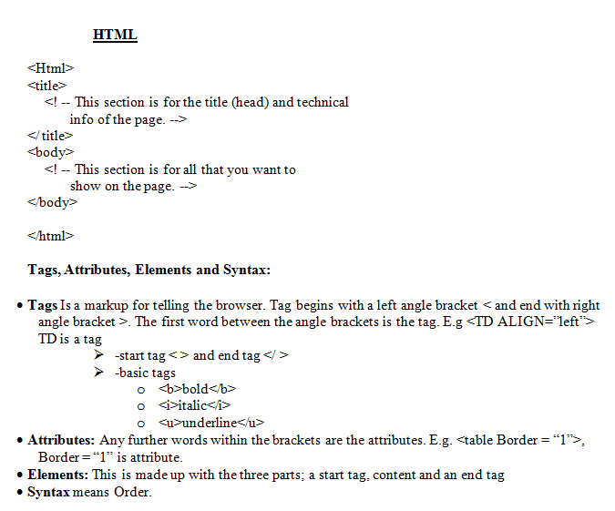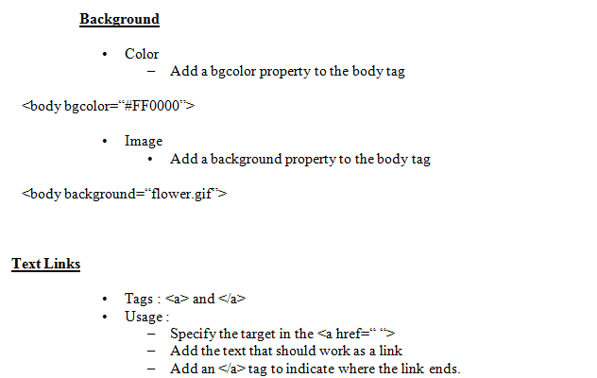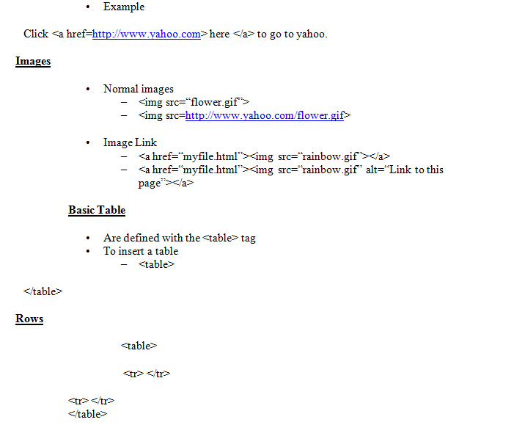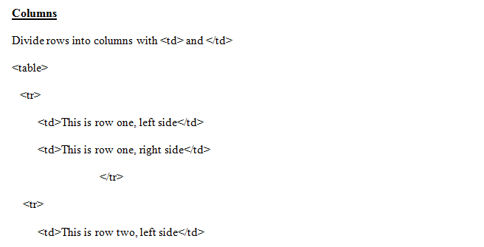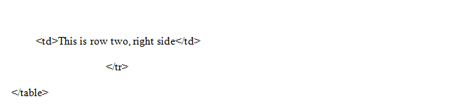

2.1.4        **Webpage Preview**

The Preview view shows an approximate view of what the page would look like in a Web browser. Things like dashed lines for tables won't appear in this view.

2.2.1        **Publishing WebPages**

Publishing WebPages is the process of copying all of the files to a remote location on a server.

2.2.2        **The importance of publishing the webpage**

The WebPages become available to other people either in World Wide Web (internet) or in Local Area (Intranet). This will enable targeted audience to access information from the website. People may download the pages they need, plus all of its associated files like forms, pictures, and so on.

2.2.3 **Procedure of transferring webpage to the web saver**

* A Web server is a computer that runs special serving software. That software "serves" HTML pages and associated files when requested by a client, such as a Web browser.
* When you use your browser to visit a site, you typically make your request by entering a URL (for example: http://example.microsoft.com). A URL is a Uniform Resource Locator. It's simply an address for a file on the Web.
* When the server receives your request, it serves or downloads the page you need, plus all of its associated files like pictures, and so on.

**Web server details**

* The URL for your site may be determined by your hosting company, but you can also register your own unique URL.
* The correct file name for your home page; home pages can be named index.htm, index.html, default.htm, or default.html depending on the kind of server your site will reside on.
* User name and password; these are often needed to publish pages to a remote server.
* Server restrictions; the total file size of your site's files may not be able to exceed a certain size or other restrictions to use certain

2.2.3        **The difference between webpage and website**

**A Webpage** is document on the World Wide Web. A Webpage consists of an HTML file, with associated files for graphics and scripts, in a particular directory on a particular machine (and thus identifiable by a URL). Usually a Web page contains links to other Web pages.

**A Website** is group of related HTML documents and associated files, scripts, and databases that is served up by an HTTP server on the World Wide Web. The HTML documents in a Web site generally cover one or more related topics and are interconnected through hyperlinks. Most Web sites have a home page as their starting point, which frequently functions as a table of contents for the site. Many large organizations, such as corporations, will have one or more HTTP servers dedicated to a single Web site. However, an HTTP server can also serve several small Web sites, such as those owned by individuals. Users need a Web browser and an Internet connection to access a Web site.

Typically, you can create a Web site on your local computer. However, the site won't be available to other people until it is eventually published—or copied—to a Web server.

2.2.5 **Access information on a website**

**Where to find a Web server**

* Where do you find a Web server? That depends on how widely available you want your site to be.

–              **World Wide Web**    If you want your site to be available on the World Wide Web, you need to find a company that offers space on their server. Companies like these are typically called Web site hosting companies. To find a Web site hosting company, search the Internet using your favorite search engine or use the URL. This will be done in the practice session at the end of this lesson.

–              **Intranet**    If you want your site to be available only to your company's intranet, then your IT department may have a server that you can use. It is also possible that your very own computer may be able to be configured as a Web server.

**How to put your Web site on a Web server**

* To put your site on a Web server, you **publish** it. Publishing generally means copying all of the files to a remote location on a server. In most cases, the remote location is either an HTTP path or an FTP path. The path you use depends on what technologies your server supports.
* FTP (the File Transfer Protocol) is a popular way to upload files to a remote server. If your server supports FTP, you would publish to an FTP location. For example, ftp://ftp.MyServer.com/myFolder. (Please note that even though you publish to an FTP path, you would still visit the site using an HTTP path in your browser.)